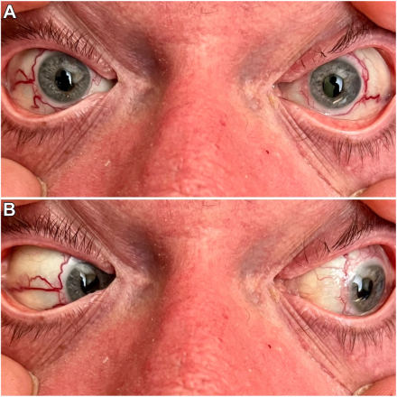

A 61-year-old man with a history of heritable pulmonary hypertension (þBNPR2) was hospitalized Thepatient developed acute, bilateral “red eye” without visual symptoms, visual acuity of 20/20, normal intraocular pressures, and symmetrically reactive pupils. Examination demonstrated bilateral, dilated circumferential conjunctival vasculature surrounding the limbus withtemporal extension (A) and relative nasal sparing (B).Based on the provided images and clinical description please make an ophthalmic diagnosis for this patient. And output the diagnostic conclusions only.

**Telangiectasias.**